19.5G network slicing environment

1. AIM
To study and simulate a 5G Network Slicing Environment, showing how multiple virtual networks (slices) can operate over the same physical 5G infrastructure with different Quality-of-Service (QoS) requirements.

2. SOFTWARE REQUIRED
Any one of the following:
- MATLAB
- Python (NumPy + basic simulation)
- Optional: Mininet/NS-3 for advanced slicing simulation (not required for simple model)

3. THEORY (Simple)
What is Network Slicing?
- A 5G feature that allows the same physical network to be divided into multiple virtual networks, each optimized for different applications.
Types of 5G Slices
- eMBB – Enhanced Mobile Broadband
  - High data rate, high throughput
- URLLC – Ultra-Reliable Low-Latency Communication
  - <1 ms latency
- mMTC – Massive Machine Type Communication
  - Thousands/millions of IoT devices
Why Slicing?
- Different applications (VR, IoT, autonomous vehicles) need different performance.
- Slicing assigns bandwidth, latency, priority separately for each slice.
Basic Idea
One physical network → multiple isolated virtual networks
Each slice has:
- Its own bandwidth share
- Its own latency requirement
- Its own traffic priority

4. PROCEDURE (Simple)
- Define three slices: eMBB, URLLC, mMTC.
- Assign bandwidth, latency, priority values to each slice.
- Generate random traffic for each slice.
- Simulate scheduling:
  - URLLC → highest priority
  - eMBB → medium
  - mMTC → low
- Allocate resources based on priority and load.
- Display total throughput and average latency per slice.

5. PSEUDOCODE (Simple)
Define slices: eMBB, URLLC, mMTC
Assign bandwidth and latency targets

Generate traffic for each slice

For each time-step:
Sort slices by priority
Allocate bandwidth
Measure throughput and latency

Print final performance for each slice

CODE:
clear; clc; close all;

%% Total available bandwidth (MHz)
BW_total = 100;

%% Slice Requirements
% eMBB: High throughput
% URLLC: Ultra low latency, high priority
% mMTC: Large number of devices, small packets

req_eMBB = 50; % Required Mbps
req_URLLC = 20; % Required Mbps
req_mMTC = 10; % Required Mbps

priority = [2 3 1]; % 1=low, 3=high priority (URLLC > eMBB > mMTC)

%% Dynamic Bandwidth Allocation
BW_alloc = zeros(1,3);
req = [req_eMBB req_URLLC req_mMTC];

% Weighted allocation based on priority
priority_weights = priority ./ sum(priority);
BW_alloc = BW_total * priority_weights;

%% Compute Throughput (T = BW * spectral efficiency)
SE_eMBB = 6; % bits/s/Hz
SE_URLLC = 4;
SE_mMTC = 1;

th_eMBB = BW_alloc(1)*1e6 * SE_eMBB / 1e6;
th_URLLC = BW_alloc(2)*1e6 * SE_URLLC / 1e6;
th_mMTC = BW_alloc(3)*1e6 * SE_mMTC / 1e6;

%% Latency Simulation (URLLC minimum)
lat_eMBB = 20 + rand*10; % ms
lat_URLLC = 1 + rand*0.5; % ms
lat_mMTC = 50 + rand*20; % ms

%% Print Results
fprintf("\n===== Network Slicing Simulation Results =====\n");
fprintf("Allocated Bandwidth (MHz): eMBB=%.2f, URLLC=%.2f, mMTC=%.2f\n", BW_alloc(1), BW_alloc(2), BW_alloc(3));
fprintf("Throughput (Mbps): eMBB=%.2f, URLLC=%.2f, mMTC=%.2f\n", th_eMBB, th_URLLC, th_mMTC);
fprintf("Latency (ms): eMBB=%.2f, URLLC=%.2f, mMTC=%.2f\n", lat_eMBB, lat_URLLC, lat_mMTC);

%% Plot Throughput Comparison
figure;
bar([th_eMBB, th_URLLC, th_mMTC]);
set(gca, 'XTickLabel', {'eMBB','URLLC','mMTC'});
ylabel('Throughput (Mbps)');
title('Slice-wise Throughput Performance');

%% Plot Latency Comparison
figure;
bar([lat_eMBB, lat_URLLC, lat_mMTC]);
set(gca, 'XTickLabel', {'eMBB','URLLC','mMTC'});
ylabel('Latency (ms)');
title('Slice-wise Latency Performance');

%% Plot Bandwidth Allocation
figure;
pie(BW_alloc, {'eMBB','URLLC','mMTC'});
title('Dynamic Bandwidth Allocation for 3 Network Slices');

OUTPUT:
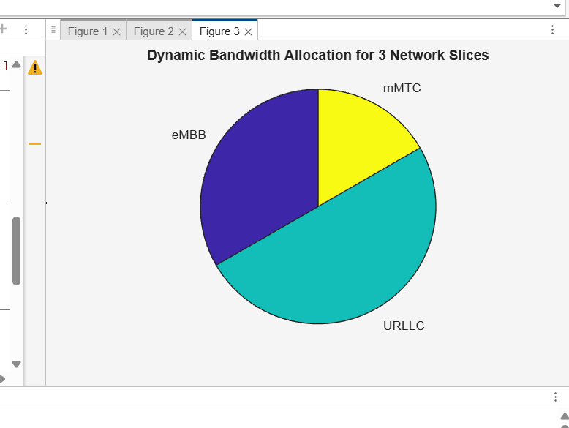
RESULT:
5G network slicing allows different virtual networks (eMBB, URLLC, mMTC) to share the same physical 5G system while each slice gets its own optimized performance for speed, latency, or device density.

